**Step1: identify entities:**

**Step2: identify key attribute/s for each entity.**

**Step 3: draw the relationships.**

According to the missing value check, a track will always be assigned to an album

And this part of code shows that a track will only belongs to one album only, an album will belong to one artist only

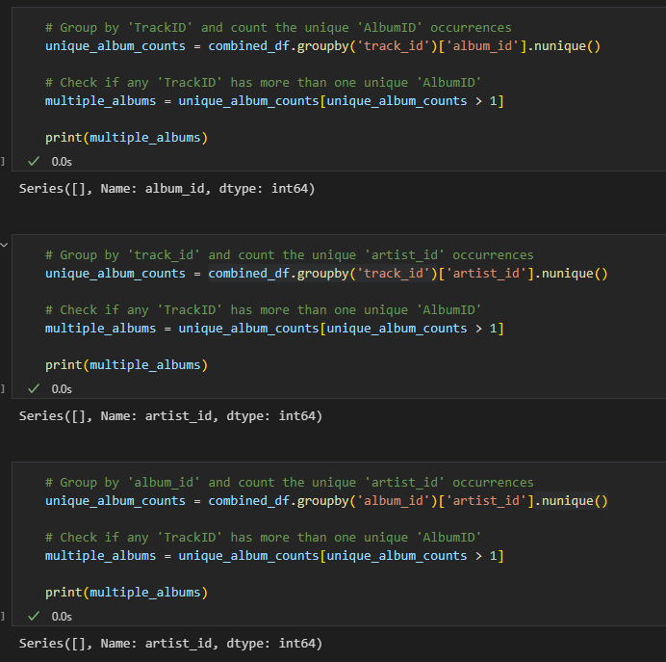

So the relationships:

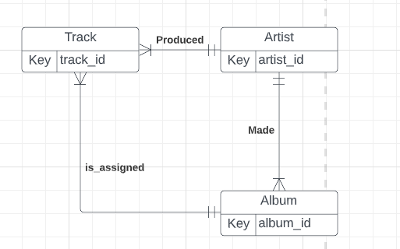

**Step 4: add non-key attributes:**